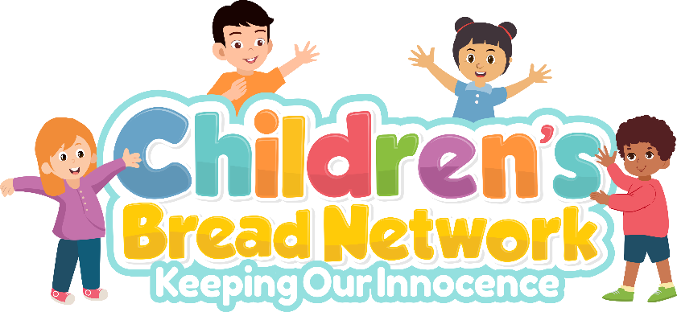

Tutoring Services for Children of All Ages

Tutoring per hour……………………………………………………………………$15 per hour

Children with IEPs are welcomed. IEP- Individualized Education Program

Your child(ren) will be assessed by me, Kentia Middleton before any decisions are made about tutoring and the amount of time (hours) or days recommended per week. The parent will be given the results of the assessment and recommendations. I will send out a contract, so that we have an agreement from child/parent and myself. We will meet on zoom. I will provide the link when contracts are signed.
If you are having financial difficulty and your child(ren) need tutoring, please contact me, and let me know so that we can discuss further. Our goal is to help children expand in every aspect of their lives.
www.freedominchristdm.com/programs

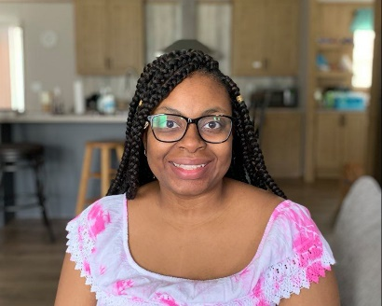
My qualifications
I am a high school and college graduate. I have a bachelor’s degree in accounting. I homeschool my 2nd grader with an IEP. I am great at taking big problems and making them smaller and easier to understand. I love working with children.

